**Airbnb and OYO**

**Developing forums follows and copies the developed ones!**

It had been evident that for decades it has been a culture among the growing and developing countries’ manufacturers and developers to imitate the Silicon Valley apps and products. Take an example, China or Japan or Korea, all of them have been the copycat nations for the decades until a few time ago. To develop their market size and success patterns, these nations have copied various features and applications from the tech giants for a long time, and have produced their cheaper copies to grasp the market.

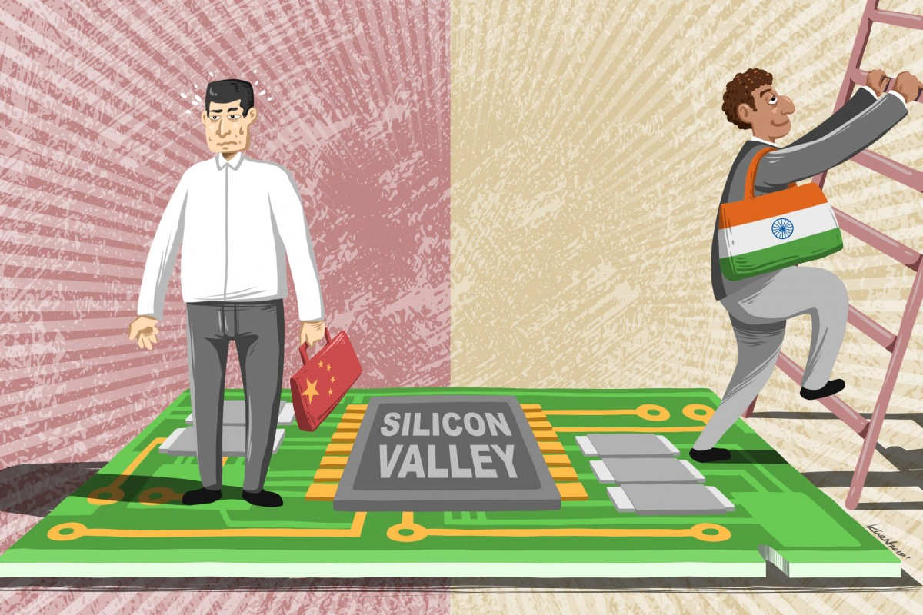

For about decades, Indian markets have been conquered and dominated by the other nation’s goods and products. Indian Smartphone market accounts for about 30% of the Chinese Xiaomi’s shares and 22% of the South Korean Samsung’s. In the digital sector too, various apps like Whatsapp, TikTok, Xender, Facebook, Airbnb, and many other foreign applications have conquered the Indian trade and market.

There has been a surge in the Indian market for “Made in India” products which is obscure to the Indian citizens of what tactics are being followed by the manufacturers and the developers for enhancing the sales of their local products. India is now moving on to the path for success by imitating and fooling its citizens in the name of “Made in India”!

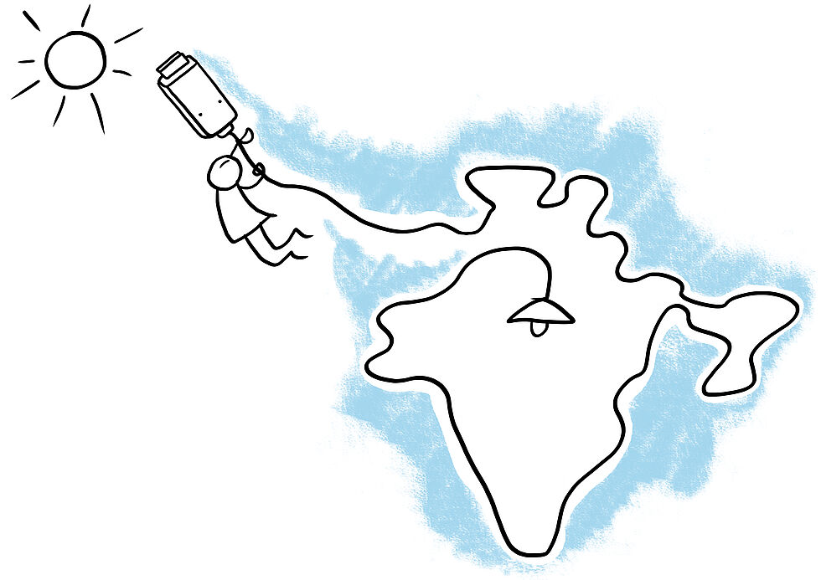

**Indian substitutes for foreign products**

Indians have developed and released various trendy applications to replace foreign apps and retake the Indian market. This movement got paced with the Galwan clash between the Chinese and the Indian troops. There is a wide range of Indian apps that have been substituting the popular “Videshi apps”, like Roposo and Sharechat for Tiktok, JioSwitch for ShareIt and Xender, JioBrowser for UC Browser and Google Chrome, Oyo for Airbnb, Amazon getting replaced by JioMart and Flipkart, and many others.

Reliance Jio’s owner, Mukesh Ambani is following his same old tactics for replacing the foreign applications by providing the discount offers and cheap prices as he did for developing the market for Jio SIM cards. Being a billionaire, Ambani is ready to face the slight losses to get the long turn success trend and patterns.

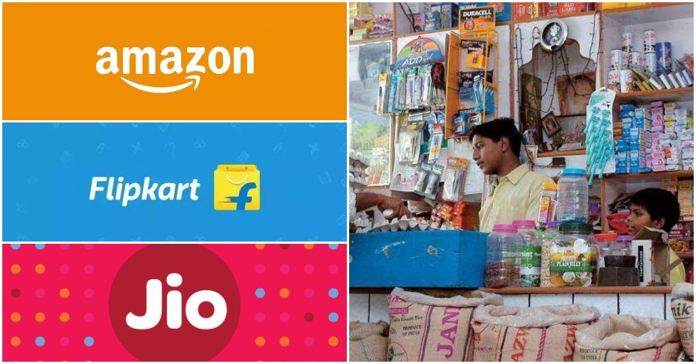

Delhi, Bangalore, and Mumbai have been the centers for most of the tech developments across the nation. The Gurugram based OYO hotels and Rooms has been the 6th largest chain operator for hotels worldwide. OYO services started with the same functionality as Airbed and Breakfast (Airbnb) and moved on making slight variances to its features. OYO hotels and Rooms have also been proven to be a copycat startup showing various similarities to Airbnb like:

* The website or the mobile application both requires setting up the account and then the location to search for the hotels and rooms available there.
* There is a list of available rooms, hotels, and rental services that are displayed on the home screen.
* The bookings can be made by clicking on the details of the hotel or the visible room.
* Payment modes can be both online as well as offline.
* Both of the service providers assign the survey duties for the maintenance to ensure the quality stays and hassle-free living.

Though there is a slight variance in the OYO services, the basic agenda and working of both the applications and websites are similar to each other.

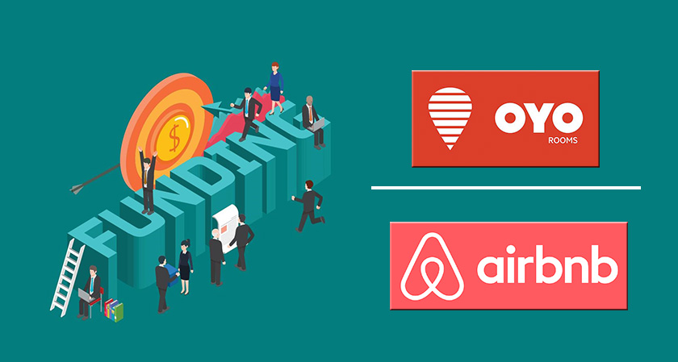

The Co-founder of Airbnb, Nathan Blecharczyk said in one of his business statements that Airbnb owns the model and hence inspires the success, and whether it is OYO or any other of the Airbnb’s clone, they haven’t been successful, and shortly too, it might not experience the similar success. This was the statement on the question of his views about OYO and Airbnb’s market shares and success. He further stated that he does not see any competition in India now. And also stated that whatever other applications come, they are either a copy of Airbnb or the one with slight variances.

**India in terms of Innovation:**

India is growing to compete with various technological giant nations like the US, China, Korea, and others. According to the DataLabs by Inc 42’s Funding report of Indian Tech Startups in 2019 stated that India has become the 5th most startup-friendly nation. However, in terms of GDP, inflation, and tax rates, lowers the comparison for the Indian economy.

Surveys state that it is the lack of funding in the Research and Development (R&D) sector that is the reason behind the giant Indian startups like Flipkart, Ola, Oyo, and others to be the imitations of the global rulers. Also, India is ranked 57 in the Global Innovation Index.

The Indian top thinker Vivek Wadhwa stated once how the Indian economy and technological advancements and developments are seen by the researchers and the thinking minds across the globe! He further stated that India will first imitate and then innovate to get to the journey of success.

Indians would first need to learn and then grow. Eventually, what Indian would be following is the Chinese trend of COPYING!

